
RAMAIAH
Institute of Technology
USN | 1 | M | S

(Autonomous Institute, Affiliated to VTU)
(Approved by AICTE, New Delhi & Govt. of Karnataka) Accredited by NBA & NAAC with ‘A+’ Grade

EXAMINATIONS SEPTEMBER /OCTOBER 2021
SUPPLEMENTARY SEMESTER / GRADE IMPROVEMENT/ RE –REGISTERED CANDIDATES
Program | : | B.E. : Electrical and Electronics Engineering | Semester | : | V
Course Name | : | Control Systems | Max. Marks | : | 100
Course Code | : | EE52 | Duration | : | 3 Hrs

Instructions to the Candidates:
- Answer any five full questions.

1. | a) | Obtain i) F-V and ii) F-I analogous circuit of the following mechanical system given in Fig 1. (A).  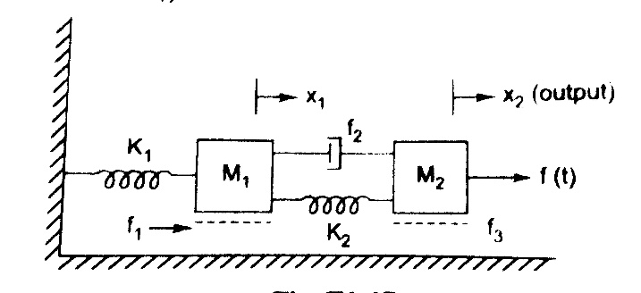  Fig 1. (A) | CO1 | (10)
 | b) | What is the necessity of mathematical modelling dynamic system?  Explain with at-least 2 examples. | CO1 | (10)
2. | a) | Differentiate open loop and closed loop systems with at least 3 examples for each. | CO1 | (08)
 | b) | Obtain i) F-V and ii) F-I analogous circuit of the following mechanical system given in Fig. 2(b).  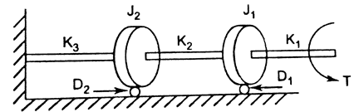  Fig. 2(b) | CO1 | (12)
3. | a) | Define i) Peak Overshoot ii) Peak Time with respect to an under damped system. Hence derive the expression for the same. | CO2 | (10)
 | b) | Derive the expression for output for a given standard second order closed loop system with damping ratio as, (assume unit step input.)  - Un-damped.  - Critically damped.  Also plot the nature of response. | CO2 | (10)
4. | a) | Derive the expression for output for a given standard second order closed loop system with damping ratio as underdamped (assume unit step input.)Plot the approximate response/graph indicating key time domain specifications. Hence prove that the un-damped system will have continuous oscillations at the output. | CO2 | (12)
 | b) | Find step, ramp and parabolic error coefficients and their corresponding steady-state error for unity feedback system having transfer function:  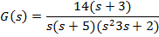 | CO2 | (08)
5. | a) | A negative unity feedback system is having OLTF,  . Find the range of K from RH criterion for which system is stable. | CO3 | (08)
 | b) | A system having OLTF 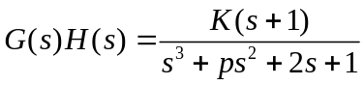, oscillates with frequency 2 rad/sec. Find values of ‘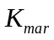’and ‘p’ if system is stable. | CO3 | (12)
6. | a) | Plot the root locus of the system with OLTF 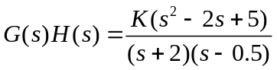. | CO3 | (10)
 | b) | The closed loop TF of positional control system is given by  .  Determine, i) The range of K for which system is stable.  ii) What should be the upper limit and lower limit of K if all the closed loop poles are required to be to the left of line s=-1. | CO3 | (10)
7. | a) | What is Lead compensator, obtain its transfer function and derive the relation between Фm and α. | CO4 | (06)
 | b) | Apply Nyquist stability criterion to find the range of K for the system with open loop transfer function G(s)H(s) = . | CO4 | (08)
 | c) | Determine the transfer function for the bode plot shown in Fig 7(c).  60 -20db/decade  dB -40db/decade  -20db/decade  0.01 0.05 0.1 jω  Fig 7(c) | CO4 | (06)
8. | a) | The open loop transfer function of a unity feedback control system is G(s) = draw Bode plot and  i) Determine the value of K for a gain margin of 10dB. What is the corresponding P.M?  ii) Determine the value of K for a phase margin of 40⁰. What is the corresponding G.M? | CO4 | (12)
 | b) | For a feedback control system, G(s)H(s) = Find the gain margin and stability from Nyquist plot. | CO4 | (08)
9. | a) | What is the Necessity of Controllers in control systems? Explain the block diagram representation of feedforward and feedback controller? | CO5 | (12)
 | b) | Write notes on PID Controller. | CO5 | (08)
10. | a) | Explain the Zeigler-Nichols method for designing PID controller. | CO5 | (12)
 | b) | What are the effects of Addition of poles and zeros in plant transfer function with respect to stability? | CO5 | (08)

****************

